These bugs are in master branch (commit id: 70a8f0ee4329b92182a50c46004243dc9aa9f5bf)

# The application is not working properly on Mobile browsers: Clicking on any of the markers does not activate the pop-up

**Observed behavior:** this only works on Desktop browser and not on Mobile.

**Expected behavior:** when clicking on a search result marker, a bubble should pop-up

# Each marker should be rounded and have a small triangle pointing to the exact spot

**Observed behavior:** it is displaying rectangular and no pointy tip

**Expected behavior:** rounded with pointy thing

# When the pop-up is open, clicking on the marker should work the same as clicking on the pop-up:

**Observed behavior:** Clicking outside the pop-up causes the pop-to go away, this is frustrating for the end-user because it is difficult to remember to move the mouse after clicking on the marker.

**Expected behavior:** Clicking in the marker should have same outcome as clicking on the pop-up.

# Excessive refreshing when the map is moved

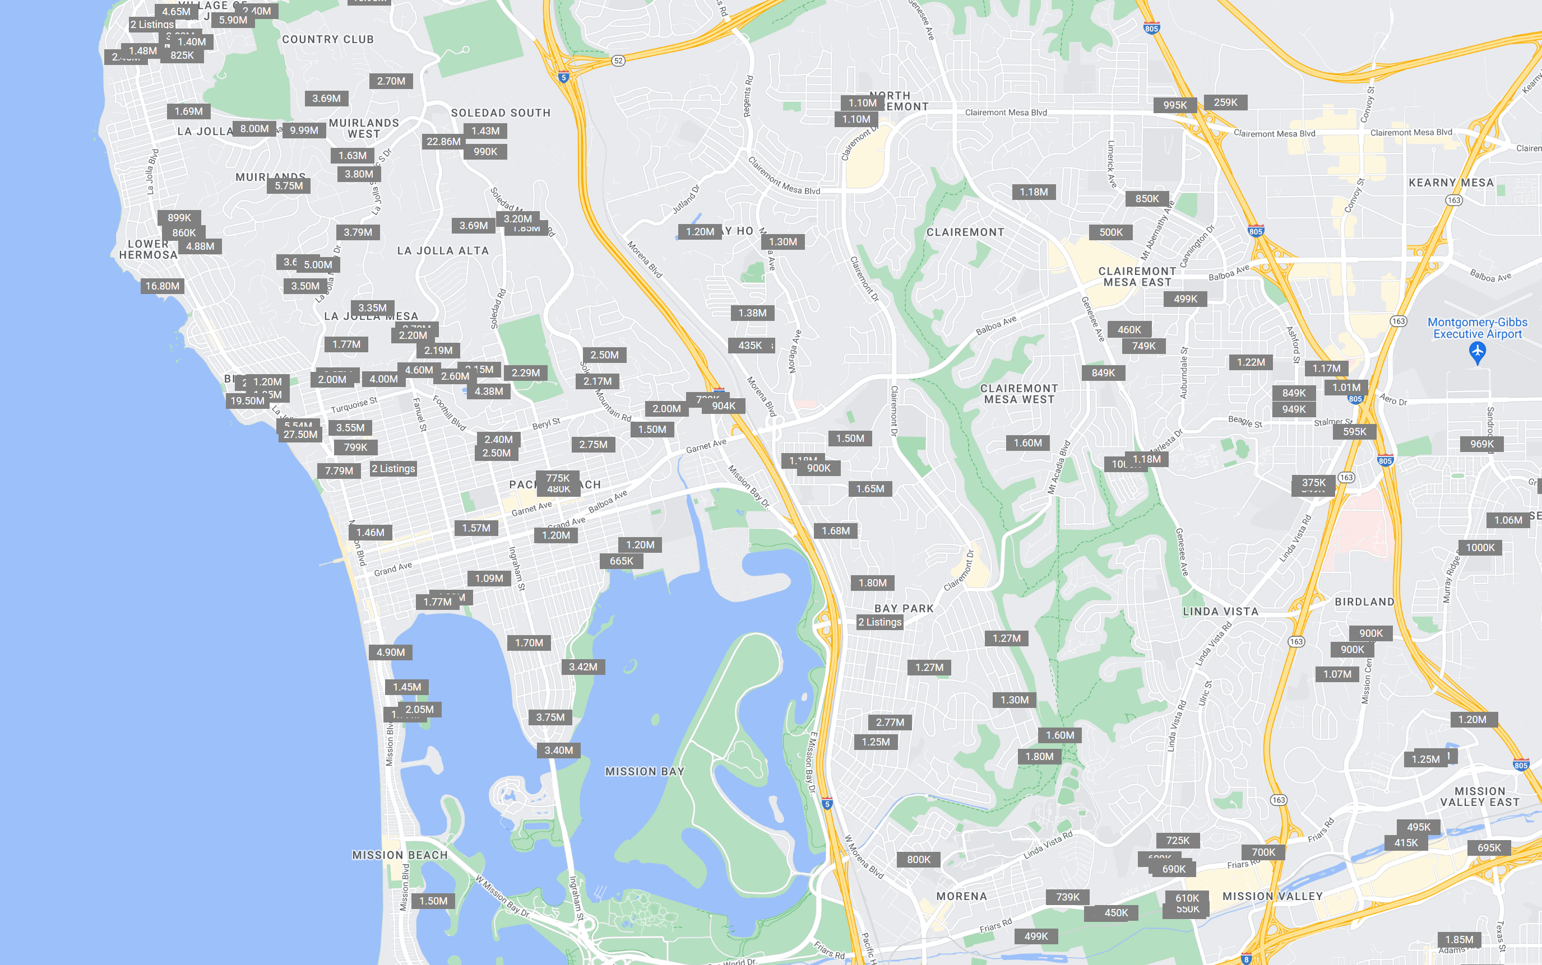

**Actual result:** Currently the entire area is re-queried and redrawn. This is slow and glitchy.

**Expected result:** Moving the map should smoothly request and paint results for the expanded area.

# The calendar under property detail shows “undefined” for the month

Steps to reproduce: click one of the result items on the map, click the photo, then scroll down in the information popup.

**Observed result:** the word “undefined” is showing

**Expected result:** the current month should be displayed in those spots.

# Refactor: Make configurable display of details

Expected and Actual Behavior for this bug are matching. The bug is actually internal to the code: this stuff should not be hardcoded. This needs to be driven by a JSON config file which sets up Section, Field Name, and Field Descrptions, and then the info sections are rendered from this JSON configuration.

# Use the COMMUNITY names from the ZIPCODES.geojson file and support autocompletion

**Observed Behavior:** Typing the COMMUNITY name does not work, the user has to type “91901” (example actual zip code).

**Expected Behavior:** the user should be able to type (for example) “Alpine” into the search box if they don’t know the zip code (91901). When the user starts typing e.g. the letter “a” … all the areas beginning with “a” should begin to autofill, e.g.:

# When nothing is typed, a Current Location option should be given

**Observed Behavior:** N/A, this currently is not implemented.

**Expected behavior:** before anything is typed, “Current Location” should show as an option. When this is clicked, the map should go to the Current Location.

# The onMouseOut event on the marker should not close the info box until the cursor is further away

**Current behavior:** veryfrustrating for the end-user to get a correct click, because the box disappears when you try to move the cursor. For example, after mouseover on the “895K” marker, if the cursor touches the street area on the way to clicking the image, the pop-up disappears.

**Expected behavior:** it should work smoothly, without frustration, even if user cursor movement is not precise. User clicks marker, then wants to click pop-up, this is the normal flow of the application. If they cannot precisely move the cursor over the white area, it should still work.

# 10. Fix the alert “An iframe which has both allow-scripts and allow-same-origin for its sandbox attribute can remove its sandboxing.”

Currently this is seen in the browser console:

